|  |  |
| --- | --- |
| **NOMBRE DEL EQUIPO** | Villabroncos de Soria |
| **RAZA** | Unión élfica |
| **ENTRENADOR** | Miki |



|  |  |  |  |  |  |  |  |  |  |  |  |  |
| --- | --- | --- | --- | --- | --- | --- | --- | --- | --- | --- | --- | --- |
| **Nº** | **POSICIÓN** | **MO** | **FU** | **AG** | **PA** | **AR** | **HABILIDADES** | **PRECIO** | **PTS. ESTR** | **PPP** | **+1 HERIDA** | **VALOR ACTUAL** |
| 1 | Blitzer | 7 | 3 | 2+ | 3+ | 9+ | Placar, Echarse a un lado | 115.000 | 4 |  |  | 115.000 |
| 2 | Línea | 6 | 3 | 2+ | 4+ | 8+ |  | 60.000 |  |  |  | 60.000 |
| 3 |  |  |  |  |  |  |  |  |  |  |  |  |
| 4 | Receptor | 8 | 3 | 2+ | 4+ | 8+ | Atrapar, Nervios de acero | 100.000 |  |  |  | 100.000 |
| 5 | Receptor | 8 | 3 | 2+ | 4+ | 8+ | Atrapar, Nervios de acero | 100.000 |  |  |  | 100.000 |
| 6 | Línea | 6 | 3 | 2+ | 4+ | 8+ |  | 60.000 | 2 |  |  | 60.000 |
| 7 | Línea | 6 | 3 | 2+ | 4+ | 8+ |  | 60.000 |  | SI |  | 60.000 |
| 8 |  |  |  |  |  |  |  |  |  |  |  |  |
| 9 | Blitzer | 7 | 3 | 2+ | 3+ | 9+ | Placar, Echarse a un lado | 115.000 | 10 |  |  | 115.000 |
| 10 | Línea | 6 | 3 | 2+ | 4+ | 8+ |  | 60.000 |  |  |  | 60.000 |
| 11 | Línea | 6 | 3 | 2+ | 4+ | 8+ |  | 60.000 |  |  |  | 60.000 |
| 12 |  |  |  |  |  |  |  |  |  |  |  |  |
| 13 |  |  |  |  |  |  |  |  |  |  |  |  |
| 14 |  |  |  |  |  |  |  |  |  |  |  |  |
| 15 |  |  |  |  |  |  |  |  |  |  |  |  |
| 16 |  |  |  |  |  |  |  |  |  |  |  |  |

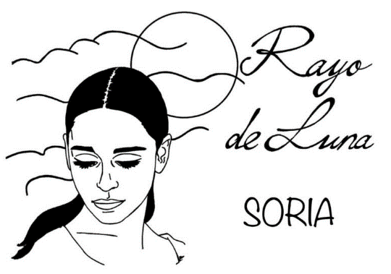

|  |  |  |  |  |  |  |
| --- | --- | --- | --- | --- | --- | --- |
| TESORERÍA | 75.000 |  | RE-ROLLS | 3 | X 50.000 mo | 150.000 |
| FACTOR HINCHAS | 1 | ASISTENTES DE ENTRENADOR |  | X 10.000 mo |  |
| TD AVERAGE |  | ANIMADORAS |  | X 10.000 mo |  |
| TOTAL HERIDAS |  | APOTECARIO |  | X 50.000 mo |  |
|  |  |  | FANS |  | X 10.000 mo |  |
|  |  |  | TEAM VALUE | 1.000.000 | | |